Ethereum Fundamentals
(important notes and highlights)

Accounts
Isolated - dapps are executed in a virtual environment known as Ethereum Virtual Machine so that if the smart contract has a bug, it won’t hamper the normal functioning of the blockchain network.
Ethereum has two account types:
- Externally-owned account (EOA) – controlled by anyone with the private keys
- Contract account – a smart contract deployed to the network, controlled by code. Learn about smart contracts
Both account types have the ability to:
- Receive, hold and send ETH and tokens
- Interact with deployed smart contracts
EOA are made up of a cryptographic pair of keys: public and private keys that control account activities. Contract accounts don't have private keys. Instead, they are controlled by the logic of the smart contract code.
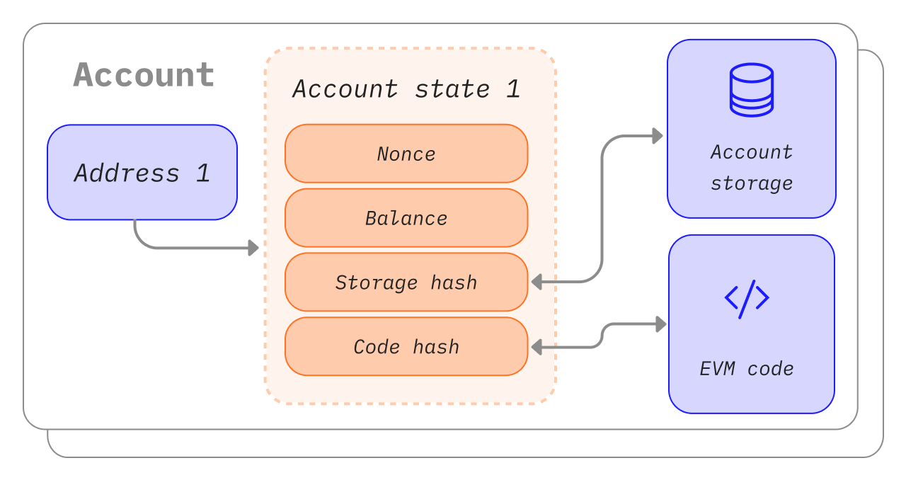
nonce – A counter that indicates the number of transactions sent from an externally-owned account or the number of contracts created by a contract account. For protection against replay attacks.
balance – The number of wei owned by this address.
codeHash – This hash refers to the code of an account on the Ethereum virtual machine (EVM). Contract accounts have code fragments programmed in that can perform different operations. This EVM code gets executed if the account gets a message call. It cannot be changed, unlike the other account fields. All such code fragments are contained in the state database under their corresponding hashes for later retrieval. This hash value is known as a codeHash. For externally owned accounts, the codeHash field is the hash of an empty string.
storageRoot – Sometimes known as a storage hash. A 256-bit hash of the root node of a Merkle Patricia Trie that encodes the storage contents of the account. This trie encodes the hash of the storage contents of this account, and is empty by default.
When you want to create an account, most libraries will generate you a random private key. The public key is generated from the private key using the Elliptic Curve Digital Signature Algorithm. You get a public address for your account by taking the last 20 bytes of the Keccak-256 hash of the public key and adding 0x to the beginning.
Contract accounts also have a 42 character hexadecimal address: Example:
0x06012c8cf97bead5deae237070f9587f8e7a266d

Transactions
An Ethereum transaction refers to an action initiated by an externally-owned account, in other words an account managed by a human, not a contract. For example, if Bob sends Alice 1 ETH, Bob's account must be debited and Alice's must be credited. This state-changing action takes place within a transaction.
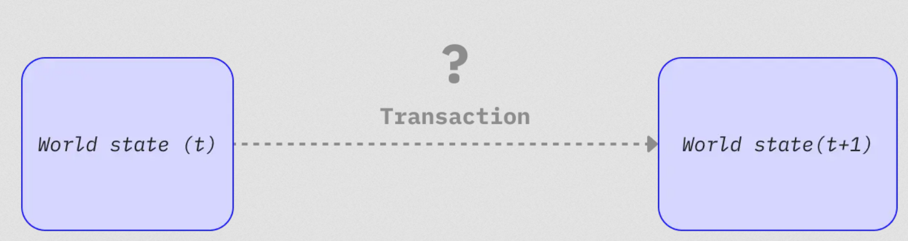
A submitted transaction includes the following information:
- from – the address of the sender, that will be signing the transaction. This will be an externally-owned account as contract accounts cannot send transactions
- to – the receiving address (if an externally-owned account, the transaction will transfer value. If a contract account, the transaction will execute the contract code)
- signature – the identifier of the sender. This is generated when the sender's private key signs the transaction and confirms the sender has authorized this transaction
- nonce - a sequentially incrementing counter which indicates the transaction number from the account
- value – amount of ETH to transfer from sender to recipient (denominated in WEI, where 1ETH equals 1e+18wei)
- input data – optional field to include arbitrary data
- gasLimit – the maximum amount of gas units that can be consumed by the transaction. The EVM specifies the units of gas required by each computational step
- maxPriorityFeePerGas - the maximum price of the consumed gas to be included as a tip to the validator
- maxFeePerGas - the maximum fee per unit of gas willing to be paid for the transaction (inclusive of baseFeePerGas and maxPriorityFeePerGas)

Types of transactions
On Ethereum there are a few different types of transactions:
- Regular transactions: a transaction from one account to another.
- Contract deployment transactions: a transaction without a 'to' address, where the data field is used for the contract code. (if we check this in Remix the to is: ContractName.constructor())
- Execution of a contract: a transaction that interacts with a deployed smart contract. In this case, 'to' address is the smart contract address. (if we check this in Remix the to is: ContractName.function())

Blocks
By spacing out commits, we give all network participants enough time to come to consensus: even though transaction requests occur dozens of times per second, blocks are only created and committed on Ethereum once every twelve seconds.

Proof-of-stake protocol
- Validating nodes have to stake 32 ETH into a deposit contract as collateral against bad behavior. This helps protect the network because provably dishonest activity leads to some or all of that stake being destroyed.
- In every slot (spaced twelve seconds apart) a validator is randomly selected to be the block proposer. They bundle transactions together, execute them and determine a new 'state'. They wrap this information into a block and pass it around to other validators.
- Other validators who hear about the new block re-execute the transactions to ensure they agree with the proposed change to the global state. Assuming the block is valid, they add it to their own database.
- If a validator hears about two conflicting blocks for the same slot they use their fork-choice algorithm to pick the one supported by the most staked ETH.

Block time
Block time refers to the time separating blocks. In Ethereum, time is divided up into twelve second units called 'slots'. In each slot a single validator is selected to propose a block. Assuming all validators are online and fully functional there will be a block in every slot, meaning the block time is 12s. However, occasionally validators might be offline when called to propose a block, meaning slots can sometimes go empty.
This implementation differs from proof-of-work based systems where block times are probabilistic and tuned by the protocol's target mining difficulty. Ethereum's average block time is a perfect example of this whereby the transition from proof-of-work to proof-of-stake can be clearly inferred based on the consistency of the new 12s block time.
You see proof of work was CPU-based but this is money based. There you needed so much electricity to do fraud, here you need billions of dollars to stake (in ETH)

Ethereum Virtual Machine (EVM)
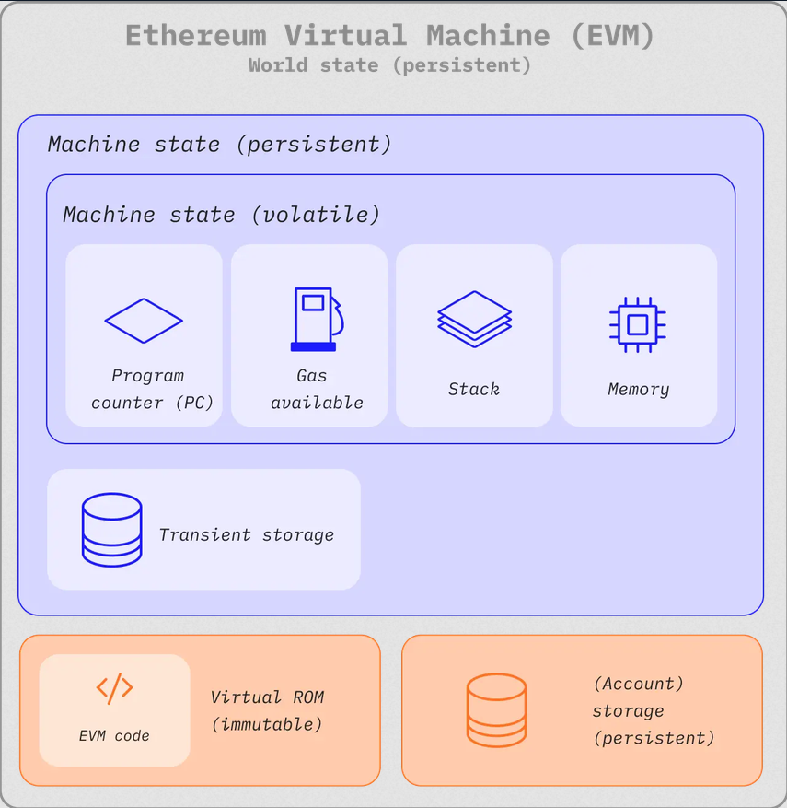
Y(S, T)= S'
Given an old valid state (S) and a new set of valid transactions (T), the Ethereum state transition function Y(S, T) produces a new valid output state S'

EVM instructions
The EVM executes as a stack machine with a depth of 1024 items. Each item is a 256-bit word, which was chosen for the ease of use with 256-bit cryptography (such as Keccak-256 hashes or secp256k1 signatures).
During execution, the EVM maintains a transient memory (as a word-addressed byte array), which does not persist between transactions.
Stack machine example:
# stack contents (leftmost = top = most recent):
push A # A
push B # B A
push C # C B A
subtract # B−C A
multiply # A*(B−C)
push D # D A*(B−C)
push E # E D A*(B−C)
add # D+E A*(B−C)
add # A*(B−C)+(D+E)

Transient storage
Transient storage is a per-transaction key–value store accessed through the TSTORE and TLOAD opcodes. It persists across all internal calls during the same transaction but is cleared at the end of the transaction. Unlike memory, transient storage is modeled as part of the EVM state rather than the execution frame, yet it is not committed to the global state. Transient storage enables gas-efficient temporary state sharing across internal calls during a transaction.
 | Memory | Transient Storage
Lifetime | One function/call frame | Entire transaction
Shared across calls? | ❌ No | ✅ Yes
Cleared | When the call returns | When the transaction finishes

Meaning the Transient storage is valid between multiple jumps from one contract to another until the transaction is over.
In solidity if you want to use transient storage, you must explicitly use TSTORE and TLOAD (typically via inline assembly) or use a library that wraps them. The same is with stack. The EVM pushes and pops from it when necessary.
----------
An important point: imagine there is a contract which is a game. I transact 10eth to the contract so that the game starts running for 3 hours. When will the state machine be updated?
The important point is:
A smart contract is not continuously running. The EVM only executes during a transaction.
So:
- You send 10 ETH → your transaction is mined (~12 seconds). An object of the contract is created in other words deployed and it will be on the blockchain forever.
- Each interaction with the game is a transaction that updates the state machine for example:
  - Tx: start_game() -> storage updates: game_started = True, Tx ends
  - Tx: pass_to_messi() [it has a front_end]
  - Tx: see_the_result()
Each transaction taking 12 seconds to happen! Not Ideal for a game like fifa!
That's why blockchain games typically:
- Keep gameplay off-chain (server or peer-to-peer).
- Use the blockchain only for important events like ownership, rewards, bets, or final outcomes.

Gas and fees
The fee is paid regardless of whether a transaction succeeds or fails.
Gas fees have to be paid in Ethereum's native currency, ether (ETH). Gas prices are usually quoted in gwei, which is a denomination of ETH. Each gwei is equal to one-billionth of an ETH (0.000000001 ETH or 10⁻⁹ ETH).
You can set the amount of gas you are willing to pay when you submit a transaction. By offering a certain amount of gas, you are bidding for your transaction to be included in the next block. If you offer too little, validators are less likely to choose your transaction for inclusion, meaning your transaction may execute late or not at all. If you offer too much, you might waste some ETH. So, how can you tell how much to pay?
The total gas you pay is divided into two components: the base fee and the priority fee (tip).
The base fee is set by the protocol—you have to pay at least this amount for your transaction to be considered valid. The priority fee is a tip that you add to the base fee to make your transaction attractive to validators so that they choose it for inclusion in the next block.
A transaction that only pays the base fee is technically valid but unlikely to be included because it offers no incentive to the validators to choose it over any other transaction. The 'correct' priority fee is determined by the network usage at the time you send your transaction—if there is a lot of demand then you might have to set your priority fee higher, but when there is less demand you can pay less.
When the block is created this base fee is "burned", removing it from circulation.
For a transaction to be executed, the max fee must exceed the sum of the base fee and the tip. The transaction sender is refunded the difference between the max fee and the sum of the base fee and tip.
Why do gas fees exist?
In short, gas fees help keep the Ethereum network secure. By requiring a fee for every computation executed on the network, we prevent bad actors from spamming the network. In order to avoid accidental or hostile infinite loops
Two cases:
- Intrinsic gas too low (rejected before execution)
  - Example: a simple ETH transfer needs at least 21,000 intrinsic gas.
  - If you set gasLimit = 20,000, the transaction is invalid.
  - It is rejected before execution, so no gas is consumed.
- Execution runs out of gas
  - Example: gasLimit = 100,000, but the contract actually needs 120,000.
  - The EVM starts executing because it cannot know in advance exactly how much gas will be needed.
  - When gas reaches zero, execution stops, all state changes are reverted, but all the provided gas is consumed.
Why can't the EVM calculate beforehand?
Because smart contracts can have dynamic execution paths.

Events and logs
Events enable your smart contract to communicate with your frontend or other subscribing applications. Once a transaction is validated and added to a block, smart contracts can emit events and log information, which the frontend can then process and utilize.
Example:
pragma solidity ^0.5.10;

contract Token {
address public owner;
mapping (address => uint) public balances;
event Transfer(address from, address to, uint amount);

constructor() public {
owner = msg.sender;
}

function mint(address receiver, uint amount) public {
require(msg.sender == owner, "You are not the owner.");
require(amount < 1e60, "Maximum issuance exceeded");
balances[receiver] += amount;
}

function transfer(address receiver, uint amount) public {
require(amount <= balances[msg.sender], "Insufficient balance.");
balances[msg.sender] -= amount;
balances[receiver] += amount;
emit Transfer(msg.sender, receiver, amount);
}
}

- The server runs the actual FIFA match in real time (off-chain).
- The match ends.
- The server submits a transaction:
recordMatch(winner, score);
- The contract:
  - Stores the result in storage.
  - Emits an event:
emit MatchFinished(winner, score);
- Your frontend (or backend) listens for that event using libraries like ethers.js or viem:
contract.on("MatchFinished", (winner, score) => {
// Update the UI
});

